Simulated Assessment Task 3.1 - Client Briefing Document

Dear Volunteer.
Thank you for agreeing to participate in the candidate’s assessment.
The candidate’s assessment includes a role-play activity in which you will take part.
To fulfil your role in the activity, review this Briefing Document carefully. Discuss any queries you may have about this document with the candidate’s assessor or training organisation.
Thank you very much, and have a good day.

Your Role
You will act as an aged care client at CareConnect College. The candidate will act as the support worker.

Volunteer Instructions

Before the activity
- Read this Briefing Document and other relevant simulated documents. The candidate’s assessor will also walk you through these documents.
- Raise any questions or concerns you may have about this document or the role-play activity with the candidate’s assessor.

During the activity
- Have this Briefing Document with you during the role-play activity.
- Participate in the role-play discussion. Follow the cues and scripts provided in the Discussion Guide section of this document.

Background

Case Study – Mobility Equipment
SCENARIO
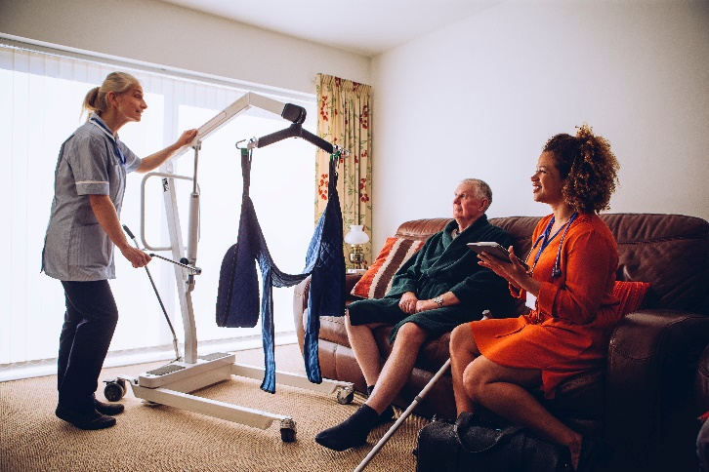
In this part of the assessment, the candidate has been requested to demonstrate the use of the following equipment to a number of trainees at CareConnect College:
- Slide sheet
- Hoist with slings
- Stand up lifter

Scenario
SCENARIO
While being observed by the assessor, the candidate will demonstrate the use of the following equipment:
- Slide sheet
- Hoist with slings
- Stand up lifter

Role Play Discussion Guide
General Disposition
- The candidate will facilitate different support activities.
- Throughout this task, you must do the following:
  - Speak slowly and clearly.
  - Allow the candidate to finish their statements or questions – do not interrupt the candidate when they are speaking.
  - Comply with the candidate’s instructions.
  - Stay consistent with the scenario. Do not introduce new elements that may interfere with or add to the existing scenario (e.g. stating that your stoma has prolapsed, asking for a back massage, etc.).
  - Refrain from making unnecessary remarks or providing feedback while the candidate is facilitating the support activities.

Part I – Repositioning the Client on the Bed Using Slide Sheet
- The candidate will get another support worker (volunteer) to assist in this transfer
- The candidate will communicate with you.
- The candidate will greet you.
  - You must also greet them.
- The candidate will explain what will happen in the support activity.
  - You must listen to what the candidate is saying.
- The candidate will ask you if you have any questions or concerns.
  - You must say that you don’t have any question so far.
- The candidate will ask for your cooperation.
  - You must agree that you will cooperate in the activity.
- The candidate will prepare the slide sheets.
  - You must lie down the bed
- The candidate will use the log roll method to position the sheet under you.
- The candidate will bend your knee and roll you towards them
  - You must cooperate with what the candidate is doing
- The candidate will ask the other support worker to insert the slide sheet from behind you
  - You must gently lift your body.
- The candidate will gently roll you onto your back
- The candidate will ask the other support worker to carefully bend your knee
- The candidate will ask the other support worker to gently roll you towards them
- The candidate will insert the other side of the slide sheet
  - You must gently lift your body
- The candidate will ask the other support worker to gently roll you onto your back.
- The candidate and volunteer will gently move you up the bed.
- The candidate and volunteer will hold the top sheet close to your body at the upper thigh and shoulder level
- The candidate and volunteer will communicate when starting the movement
  - You will let your body move towards where they are headed
- The candidate and volunteer will safely slide you up the bed using the slide sheets
  - You will let your body gently slide up the bed
- The candidate and volunteer will refrain from lifting the slide sheets
Part II – Repositioning the Client from the Bed to the Chair Using a Hoist with Slings
- The candidate will get another support worker (volunteer) to assist in this transfer
- The candidate will communicate with you.
- The candidate will greet you.
  - You must also greet them.
- The candidate will explain what will happen in the support activity.
  - You must listen to what the candidate is saying.
- The candidate will ask you if you have any questions or concerns.
  - You must say that you don’t have any question so far.
- The candidate will ask for your cooperation.
  - You must agree that you will cooperate in the activity.
- The candidate will prepare the slings.
  - You must lie down the bed
- The candidate will position the slings under you.
- The candidate will adjust your bed to a safe and comfortable height
- The candidate will place your arms over your chest
  - You must let your arms cross over your chest
- The candidate will ask the volunteer to bend one of your knees
  - You must let your knee bend
- The candidate will gently roll you towards them
- The candidate will ask the volunteer to insert the slings from behind you
  - You must gently lift your body
- The candidate will gently roll you onto your back
- The candidate will assist you to roll to the opposite side
  - You must let your body roll to the other side
- The candidate will spread the slings into position
- The candidate will prepare the sling for attachment to the hoist
- The candidate will pass the leg straps underneath your thighs
  - You must gently spread your legs
- The candidate will clip the slings to opposite sides
- The candidate will position the hoist and bring it closer to you
- The candidate will adjust and lower the spreader bar to attach the slings to the top and bottom parts of the spreader bar
- The candidate will assist in transferring you from the bed to the chair by lowering down the height of the bed while the other support worker supports your head
- The candidate will slowly raise the sling using hoist controls
  - You must be hanging above the bed while inside the slings. You will show that you are uncomfortable.
- The candidate will adjust and reposition the sling.
- The candidate and the volunteer will move the hoist toward the direction of the chair
- The candidate will position you over the chair while slowly bringing the hoist down
- The candidate will ask the volunteer to support the sling while being lowered down
- The candidate will slowly guide the sling to position you to the chair
- The candidate will ask if you are comfortably sitting
  - You will say “Yes”.
- The candidate will remove the sling out from your legs and you will be asked to lean forward.
  - You must gently lean forward.
- The candidate will pull the slings from behind you and will ask if you are comfortably sitting.
  - You will say “Yes”.

Part III – Assisting the Client in Standing Up Using a Stand-Up Lifter
- The candidate will get another support worker (volunteer) to assist in this transfer
- The candidate will communicate with you.
- The candidate will greet you.
  - You must also greet them.
- The candidate will explain what will happen in the support activity.
  - You must listen to what the candidate is saying.
- The candidate will ask you if you have any questions or concerns.
  - You must say that you don’t have any question so far.
- The candidate will ask for your cooperation.
  - You must agree that you will cooperate in the activity.
- The candidate will assist you in sitting down.
  - You must sit down properly with your feet touching the ground.
- The candidate will prepare the slings.
- The candidate will assist you in wearing the sling by asking you to lift your arms.
  - You must gently lift your arms.
- The candidate will place the sling around your waist and under your arms and gently fasten them.
- The candidate will ask for the volunteer’s assistance in wrapping the slings around your body.
- The candidate will ask you to bring your arms down.
  - You must gently drop your arms.
- The candidate will ask for the volunteer’s assistance to accompany you while they position the stand-up filter.
- The candidate will position the stand-up lifter by widening the leg of the lifter and bringing it slowly in front of you.
- The candidate will assist you in lifting your legs and putting them on the footplate.
  - You must put your feet on the footplate.
- The candidate will bring the lifter closer, so your knees are close to the kneepads.
- The candidate will ask you to lean forward.
  - You must gently lean forward.
- The candidate will attach the loops of the slings on the hooks of the lifter.
- The candidate will ask you to lean back and hold on to the handles of the lifter.
  - You must gently lean back and hold on to the handles.
- The candidate will inform you before adjusting the height of the lifter.
- The candidate will turn on the switch of the stand-up lifter.
- The candidate will ask you to gently push your legs down.
  - You must push your legs down.
- The candidate will ask for the volunteer’s help in assisting you as you get up
- The candidate will gently move the stand-up lifter from the place to the transfer point.
- The candidate will assist you in sitting down.
- The candidate will let you know that you are already in the transfer point.
  - You must nod and smile.
- The candidate will ask for the volunteer’s assistance as the lifter goes down
- The candidate will slowly lower down the lifter and ask you to lean forward while they remove the slings from the hooks.
  - You must gently lean forward.
- The candidate will then ask you to sit back.
  - You must sit back.
- The candidate will lift your feet up and move the lifter away from you.
  - You must sit properly with your feet touching the ground.
- The candidate will assist you in removing the slings and will ask you to move forward.
  - You must lean forward.
- The candidate will now remove the sling from behind you.
End of Briefing Document

